Jalasoft Engineering Documents

Test Cases
Training Documents

Jalasoft Engineering Documents
Last Updated: March 25, 2008


_{J}alasoft Strategy on Test Cases

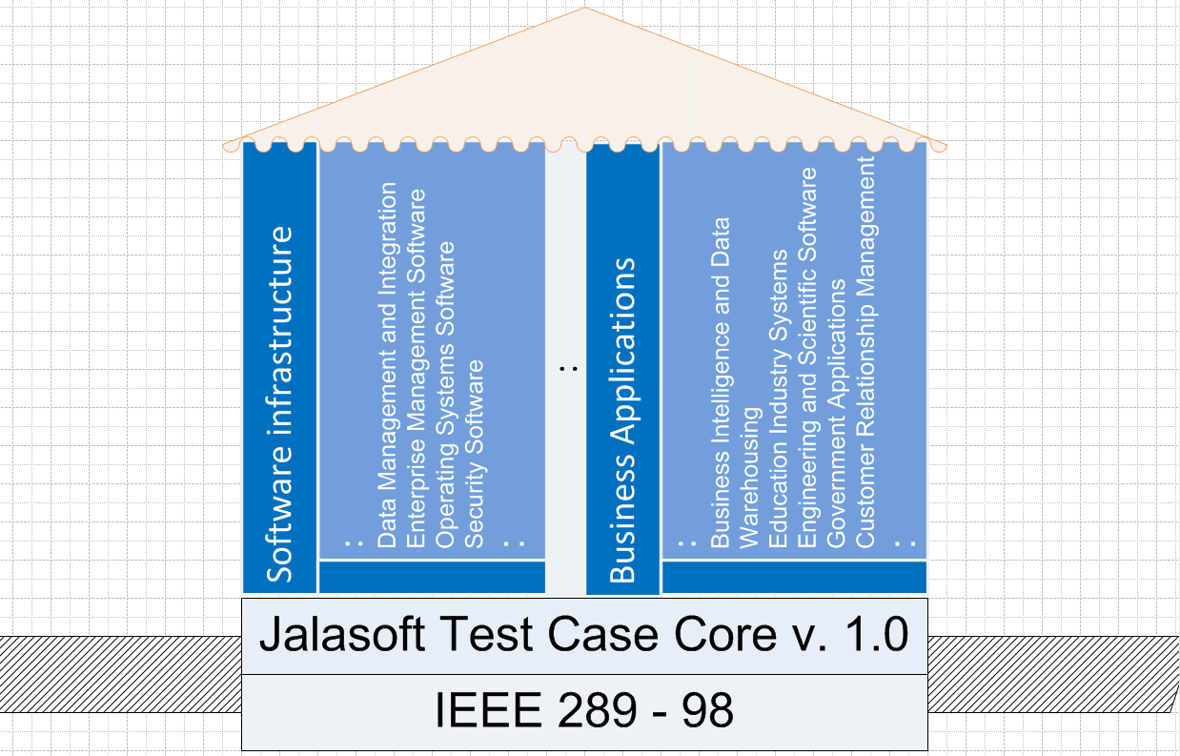
Vertical X
Vertical B
Vertical A
Test Cases adapted to verticals
Foundation: Jalasoft Test Case Core v1.0
IEEE Standard 829 - 1998
Standardization of TC
IEEE Std. 829 - 1998

The aim of this document is to discuss Jalasoft strategy on Test Cases, explain its logic and origins. As the graphic shows, the strategy is essentially based on the IEEE Standard 829 -1998. Compliance with this standard allows building strong foundations to standardize the Test Cases (TC) documentation in the company. All projects will adopt Jalasoft Test Cases Core v1.0, a template that includes the fields suggested by the above mentioned standard and is a result of the company experience in SQA.

On the other hand, some Quality Engineering teams might need to complement the TC Core template with specific fields, according to their project, product being tested and related industry. That is the reason to create verticals, categories that will regroup similar projects and that must share the TC Core but also the vertical specific fields.

The following two sections explain the origins of Software Quality Assurance and Software Testing. After going over those foundational concepts, the document elaborates on Test Cases—including a Test Cases Lifecycle explanation, the fields standardized on the TC Core, those used in Software Testing Tools and Test Cycles, verticals concept and classification.

_{Q}uality Assurance Context

Quality Assurance History and Definition

Adapted from sqa.net
The so called Quality Movement which was first established in Japan in 1946 by the U.S. Occupation Force's,
was based on W. Edwards Deming (USA) research and papers on Statistical Quality Control (SQC).
The various definitions and approaches to Quality Assurance come from Deming and other so called Quality Gurus.
The important point, for this discussion, is that these methods were applied to industrial production.
That is the production of something tangible. Fujitsu’s slogan Quality built-in, with cost and performance as prime consideration, typifies this approach. Under this approach the production process was broken down and specified.
Each process would have an output (or component) that would have a required specification (measurement, weight etc.) and these would be verified as the main product was being built.
It would be a separate group Quality Control (QC) that would measure the components, at various manufacturing stages. QC would make sure the components were within acceptable “tolerances”, i.e. they did not vary from agreed specifications. It is worth noting here that in manufacturing QC (or test and inspection) is easy to distinguish from Quality Assurance QA which is process compliance. In Software development, however, Quality Control itself presents significant challenges due to the intangible nature of Software.
In Software development the distinction between QC (SQC) and QA (SQA) is not as clear and these terms are often mixed.
These QA methods, in manufacturing, proved themselves to work (in Sales, Customer satisfaction and the right cost of production, i.e. PROFIT) and were adopted all over the world. QA groups (for manufacturing) became the norm. These QA groups would not take any part in the manufacture process itself but would measure and audit the process to make sure the established guidelines and standards where being followed.
The QA group would then give input (metrics or measures ) into a process of continuous improvement. In this way we could have a QC department that measures certain components at various manufacturing stages and have a QA department that makes sure that every process (including QC) is following the agreed and documented procedures. In short we had someone (QA) assuring that processes were conforming to document standards and procedures, hence these terms showing up in SQA and QA definitions, and this group were distinct from QC (i.e. testing).
So far we are in great shape in the QA and QC world of manufacturing, then someone came up with the bright idea Why don't we apply these proven Quality Management processes to Software?
The move to SQA and SQC
Hence SQA (and SQC) were born and with it came problems of definition and implementation. The definition still refers back to the traditional manufacturing QA world.
There are, however, some notable differences between software and a manufactured product.
These differences all stem from the fact that the manufactured product is physical and can be seen whereas the software product is not visible. Therefore its function, benefit and costs are not as easily measured.
The following differences highlight some of the issues in taking the manufacturing QA\QC model and applying it to software development.
- The manufactured product is a physical realization of the customer requirements.
- The function of the product can be verified against this physical realization.
- The costs of manufacture, including rework, repairs, recalls etc., are readily categorized and visible.
- The benefits of the product to its user\customer are readily categorized and visible.

In order to overcome these types of issues, and reap the benefit of QA\QC applied to software, other terms, models and paradigms needed to be (and were) developed.
In order to identify the Software Costs and Benefits, remembering Fujitsu’s term with cost and performance as prime consideration, a number of Software Characteristics where defined. These characteristics are sometimes referred to as Quality Attributes, Software Metrics or Functional and Non-Functional Requirements.
The intention here is to breakdown the Software product into attributes that can be measured (in terms of cost benefit). Examples of these attributes are Supportability, Adaptability, Usability and Functionality. There are many definitions of these Software Quality Attributes but a common one is the FURPS+ model which was developed by Robert Grady at Hewlett Packard. Under the FURPS, the following characteristics are identified:
Functionality
The F in the FURPS+ acronym represents all the system-wide functional requirements that we would expect to see described.
These usually represent the main product features that are familiar within the business domain of the solution being developed.
For example, order processing is very natural for someone to describe if you are developing an order processing system.
The functional requirements can also be very technically oriented.
Functional requirements that you may consider to be also architecturally significant system-wide functional requirements may include auditing, licensing, localization, mail, online help, printing, reporting, security, system management, or workflow.
Each of these may represent functionality of the system being developed and they are each a system-wide functional requirement.
Usability
Usability includes looking at, capturing, and stating requirements based around user interface issues, things such as accessibility, interface aesthetics, and consistency within the user interface.
Reliability
Reliability includes aspects such as availability, accuracy, and recoverability, for example, computations, or recoverability of the system from shut-down failure.
Performance
Performance involves things such as throughput of information through the system, system response time (which also relates to usability), recovery time, and startup time.
Supportability
Finally, we tend to include a section called Supportability, where we specify a number of other requirements such as testability, adaptability, maintainability, compatibility, configurability, installability, scalability, localizability, and so on.
+
The "+" of the FURPS+ acronym allow us to specify constraints, including design, implementation, interface, and physical constraints.
The specification of the FURPS+ characteristics needs to go into the Systems Requirements.
The testing of these characteristics should be done by the SQC (testing team). Some of the FURPS+ characteristics, i.e. Functionality and Usability can be tested by executing the actual software. Some, however, like Supportability and Adaptability can only be verified by code inspection or dry running What if? scenarios.

It is important to note that neither the SQA nor SQC group should have the responsibility of putting the desired FURPS+ characteristic into the product. They (SQC) should only test the presence or absence of the FURPS+ characteristics. This, however, does not imply that the SQA and SQC team does not work together with development. In fact, the software industry is increasingly asking them to merge into one goal and quality-oriented team. They are both responsible to create the product.

With an established practice of defining and measuring the FURPS+ (or similar model) characteristics it is possible to implement Software QA\QC along similar lines to manufacturing QA\QC.
This should, in theory, overcome the difficulties caused by the intangible nature of software, allowing each Characteristic of the Software to be measured (by SQC) and subject all the processes of Software production to SQA and continuous improvement.

By way of example, consider the Supportability FURPS+ characteristic. This can be measured by the length of time it takes to fix a defect. In order to improve this measure coding standards could be implemented. In this scenario the SQC department would inspect the code to make sure that the coding standard was being implemented and the SQA department would make sure the SQC and the development group followed the process.

The SQA department would also collect and analyze the time needed to repair the defect (Supportability measure) in order to give input to the usefulness of the standards as well as to the continuous process improvement initiative.
Conclusion on SQA and SQC
The definitions for SQA and SQC originate from their manufacturing QA and QC counterparts. SQA and SQC can be implemented in Software production as their QA and QC counterparts are in manufacturing.
In order to implement SQA and SQC (as their manufacturing counterparts) a method of characterizing the intangible software product is needed. The FURPS+ model defines a system of characterization, under which software attributes can be used by SQC to Test and Measure. Anything that is tested and measured (by SQC) needs to be defined as a requirement, this includes the FURPS+ characteristics.

